Amendment A Sand Creek Pre-Bid Meeting Questions
4/15/26
- Can we send out sign-in sheet? Yes
Unit weight for bridge components. 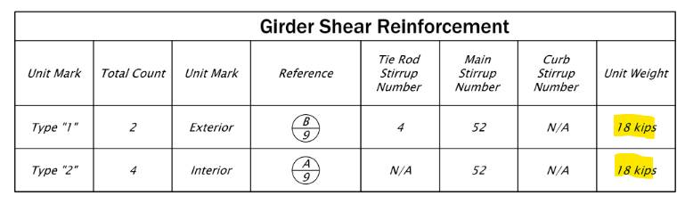
18 kips = 18,000 lbs
Here are the weights of the abutment/footing blocks:
- "A" blocks = 4,000 lbs each
- "B" blocks = 7,000 lbs each
- "C" blocks = 11,200 lbs each

- Bypass is contractor’s responsibilities and must be able to have emergency vehicles cross.
- Sand Creek Attachment A is now online at www.lewisconservationdistrict.com under the Open Bids tab
- The coordination of the utilities will be done by the Conservation District. The District will do the initial locate but the contractor will be responsible for doing one before they dig.
- Conservation district will pay for the power and phone to be moved.
- Spoils will go onto Blaine’s property.
- No monuments in the road. The engineer looked for them and it appears they have been road graded out.
- The contract states that the project must be substantially complete in 10 days. The work can be done anytime within the fish window. However, please try to limit the amount of time the locals have to use the bypass road.
- Summer flows are typically low in this stream.

