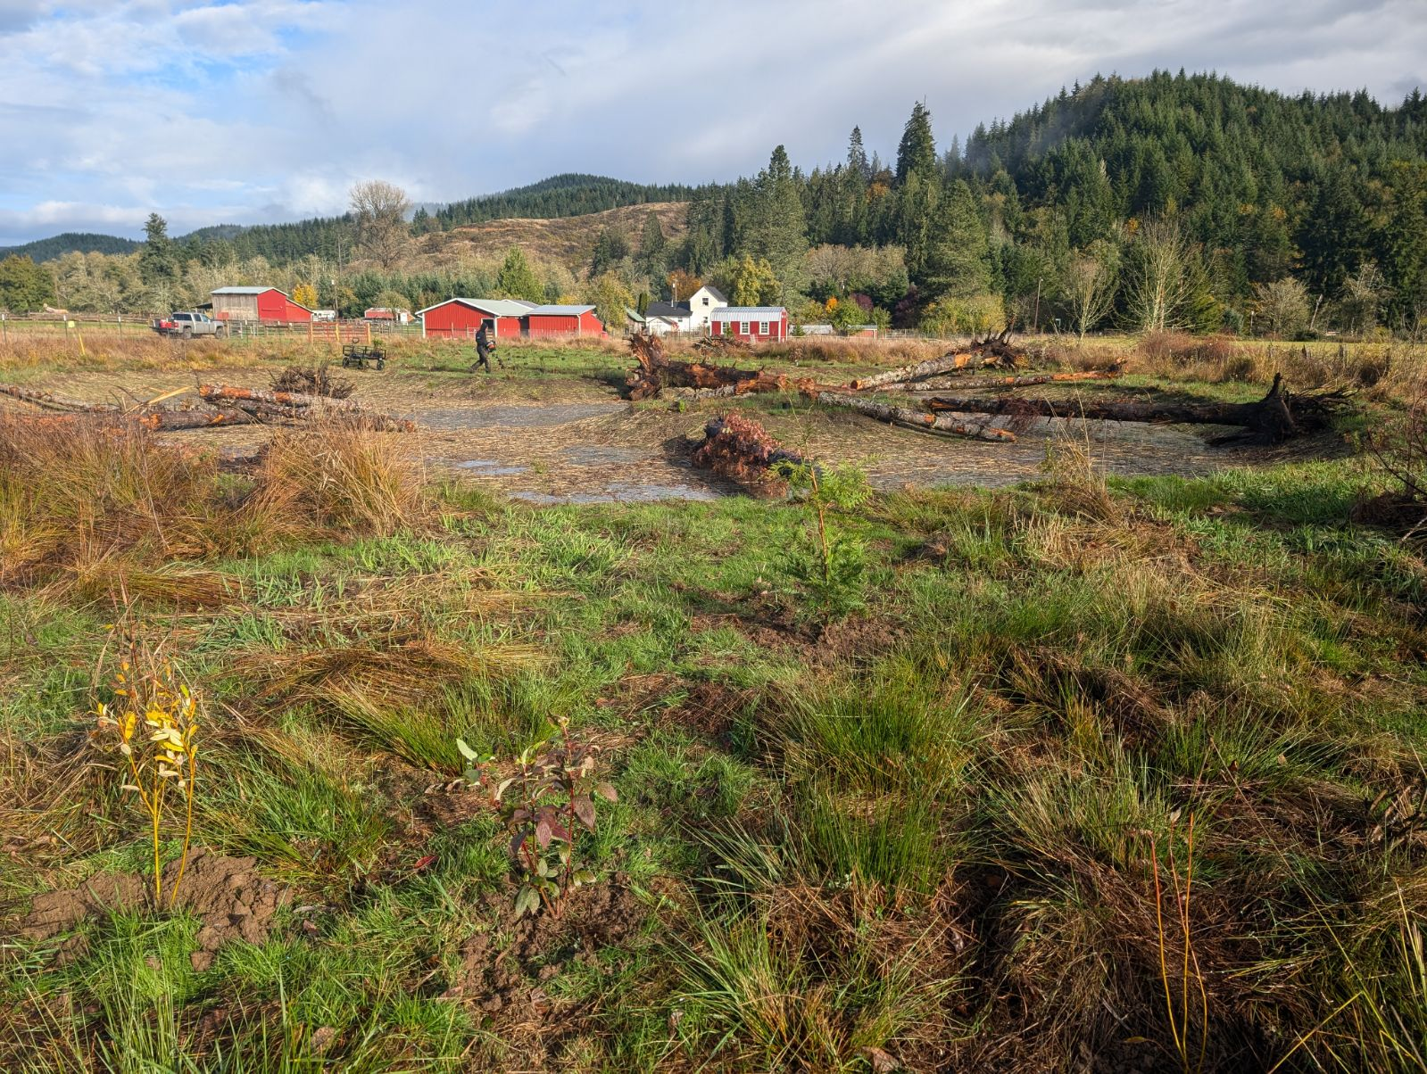
Lewis Conservation District

Five-Year Plan for 2026-2031

Contact: Nikki Atkins,

Nikki.Atkins@lewiscdwa.com

(360)996-4560

Table of Contents

Organization of the Lewis Conservation District 3
Function of Lewis Conservation District 3
Mission of the Lewis Conservation District 3
Vision of the Lewis Conservation District 3
Values of the Lewis Conservation District 4
Purpose of the plan 4
Lewis Conservation District Strategic Goals and Objectives 4
Key Considerations, Issues, and Challenges 6
Appendices 7
Appendix A: Natural Resources Data 8
Appendix B: Priority Geographic Areas 9

Organization of the Lewis Conservation District
A political subdivision of the State of Washington – authorities, powers, and structure contained in RCW 89.08.

- On January 4th, 1943 Washington State Secretary of State Belle Reeves signs the certificate creating Lewis County Conservation District. The conservation district boundaries encompass all the area in Lewis County including the incorporated cities.
- The district is governed by 5 supervisors; three are elected and two are appointed by the Washington State Conservation Commission The Lewis Conservation District serves all stakeholders in the county and works with all those interested in protecting and preserving natural resources.
- We provide assistance to promote and maintain best use(s) of natural resources: to achieve good stewardship of natural resources; to enhance, sustain and protect natural resources and to educate those we serve in the importance of natural resources for sustaining the quality of life in Lewis County for future generations.

Function of Lewis Conservation District
To take available technical, financial, and educational resource, whatever their source, and focus or coordinate them so that they meet the needs of the local land managers with conservation of soil, water and related natural resources.

Mission of the Lewis Conservation District
Lewis Conservation District provides technical, educational, and financial assistance for the conversation, protection and development of natural resources within Lewis County.

Vision of the Lewis Conservation District
- To have all private landowners in the County aware of the District, what it does and how the District can assist them. Have all landowners understand that the District is not part of the County Government and is not the USDA Natural Resources Conservation Service.
- To encourage landowners to actively participate in conservation actions, personally and collectively.
- To have enough available water for all beneficial uses including domestic, irrigation and aquatic habitat by developing water storage and implementing water conservation practices, and by leveraging the maximum amount of funding possible for these activities.
- To reduce the need of regulatory agency interventions by working collaboratively with landowners and regulatory agencies to address issues before regulations become necessary.
- To implement strong conservation programs that address the quality and quantity of water resources in the county and balance competing demands on those resources.
- To improve the ability to get financial and technical assistance to the appropriate and most beneficial projects.
- Maintain and improve soil health to promote viable, productive agriculture and forestry and encourage carbon storage.

Values of the Lewis Conservation District
- Trust  - Local solutions to local issues  - Help landowners with stewardship  - Voluntary  - Non-regulatory  - Partnerships  - Honesty  - Fiscal responsibility  - Dynamic | - Quality of Product  - Efficiency  - Results-oriented  - Commitment  - Transparency  - Responsive  - Friendly, personable  - Respectful

Purpose of the plan

The primary purpose of the long-range plan is to develop, and agree to, the overall direction, of the district and its programs. This involves establishing milestones (or goals), rather than a detailed year-by-year outline. In addition, the long-range planning process is an ideal opportunity to evaluate needs/gaps in funding, staffing, capacity, infrastructure, etc. that will be critical to implement the plan over the term of the plan and to develop strategies to address those needs. Strategic plans are grounded in a long-term vision but must be flexible in that they are able to adapt to a changing operating climate and thus should be reviewed regularly to see if adjustments are needed.

Lewis Conservation District Strategic Goals and Objectives
Overarching Goals and Objectives
For all of Lewis’s program goals and objectives we will apply the following large-scale goals:
- Provide fair and equitable programming for Lewis County residents
- Strive to meaningfully engage with Tribal Partners
- Provide opportunities for Adult and Youth Education
- Serve underserved producers through equitable program approaches
Agricultural Sustainability Goals
Goal 1: Keep Agriculture Viable in Lewis County
Objective 1: Seek incentives to keep farms economically viable
Goal 2: Determine Cooperator conservation needs
Objective 1: Develop and conduct survey on technical assistance and cost share needs for soil
health, irrigation efficiency, energy efficiency, and farmland preservation
Objective 2: Develop an implementation plan for meeting cooperator needs for adult education, engagement, technical assistance and cost share.
Goal 3: Grow cooperator assistance programs
Objective 1: Seek funding to provide technical assistance and cost share opportunities for cooperators to implement conservation practices. This includes soil health, irrigation efficiency, energy efficiency, and other on-farm practices that improve agricultural sustainability.
Objective 2: Promote and grow programs that improve utilization of branding opportunities such as Salmon-safe, and/or connect cooperators with market opportunities such as farmers markets, Grain co-op, restaurants and other venues.
Objective 3: Continue to eradicate knotweed in Chehalis Basin and seek funding to eradicate knotweed in Cowlitz Basin.
Goal 4: Increase partnerships with organizations that provide resources to cooperators
Objective 1: Increase engagement with cooperator associations (such as irrigation, cooperatives, peer networks, farm co-ops, etc.) to provide more opportunities for their members.
Objective 2: Work with partners to highlight resources available to cooperators. Programs include, but are not limited to NRCS Cost Share (Environmental Quality Incentive Program (EQIP, Conservation Stewardship Program (CSP)), Voluntary Stewardship Program, Washington State Conservation Commission Cost Share, etc.
Goal 5: Set up mentoring program, farmers helping farmers
Objective 1: Develop program so knowledgeable farmers can mentor less experienced farmers.
Objective 2: Develop how to videos sharing knowledge on agricultural topics
Habitat Restoration Goals
Goal 1: Improve water quality
Objective 1: Identify, seek funding, and complete water quality projects, in Chehalis and Cowlitz basin.
Objective 2: Develop an implementation plan for meeting cooperator needs for education and engagement.
Goal 2: Improve fish and wildlife habitat
Objective 1: Provide technical assistance and project opportunities for Chehalis Basin Residents.
Objective 2: Seek funding and provide technical assistance and project opportunities for Cowlitz Basin residents
Goal 3: Continue partnerships with organizations that provide resources to Lewis County landowners.
Objective 1: Continue engagement with habitat centric associations (such as Office of Chehalis Basin, peer networks, Cowlitz Lead Entity, etc.)
Objective 2: Work with partners to highlight resources available to cooperators.
Education and Outreach Goals
Goal 1: Increase Community Awareness and Education
Objective 1: Increase public awareness of Lewis Conservation District, its programs and projects.
Objective 2: Targeted outreach to support specific project development and program participation.
Objective 3: Provide workshops, farm tours and other educational content
Objective 4: Increase our presence at community events.
Objective 5: Keep content of website updated to provide important and pertinent conservation information.
Flood and Fire Goals
Goal 1: Firewise Education
Objective 1: Seek funding to provide technical assistance and cost share opportunities for landowners to implement Firewise practices.
Goal 2: Flood reduction/mitigation
Objective 1: Support Chehalis Basin Dam Construction.
Objective 2: Work with landowners to prepare and mitigate potential flood damage.

Key Considerations, Issues, and Challenges
Key Decision Makers
Strategic Priority | Key Decision Makers
Water quality (stormwater, nutrient management, sediment, riparian buffers, bank stabilization) | - District Board and Staff  - Conservation Commission  - Land Managers  - VSP Workgroup
Flood Control | - District Board and Staff  - County Commissioners
Salmon/Aquatic Species Recovery and Protection | - District Board and Staff
Enhancing Agriculture and Forestry Production | - District Board and Staff  - VSP Workgroup
Water Quantity | - District Board and Staff  - VSP Workgroup
Invasive Species | - County Commissioners  - District Board and Staff  - Weed Control Board  - General Public  - VSP Workgroup
Education | - District Board and Staff  - VSP Workgroup
District Operations & Funding | - District Board and Staff  - Conservation Commission

Land Manager Needs:
The Lewis Conservation District consistently receives requests for completing and updating conservation and dairy nutrient management plans. This leads to requests for cost share to implement plans to protect natural resources and to manage nutrients to optimum levels for forage production.
We also receive numerous requests for assisting with bank stabilization and habitat projects.
Annually, we sponsor land managers in completing fish passage projects.
We continue to assist landowners with assessing, planning and implementing the Conservation Reserve Enhancement Program and Riparian Grant Program.
We will continue working with cooperators on Irrigation Water Management Plans. We are anticipating several cooperators requesting to have plans updated/completed.

Staffing Needs
- Current Staff - 6 positions – District Manager, Special Projects Coordinator, Habitat and Riparian Manager, Crew Member x2 and Administrative Assistant
- Would add an additional Habitat Specialist and a VSP technician
- Increase staffing capacity for additional workload through available funding sources

Appendices
Appendix A: Natural Resources Data
Appendix B: Priority Geographic Areas

Appendix A: Natural Resources Data
- Current acreage in agriculture in Lewis County is approximately 118,915 acres (USDA data). The number of farms has decreased by 9% since 2017. Lewis County has approximately 72% of its land in forest resource uses, which is over 1.8 million acres, with the majority being privately owned. A significant portion is also designated as National Forest land, with the Gifford Pinchot National Forest covering over 1.3 million acres within its boundaries, according to US Forest Service. Both agriculture and forestry landowners request assistance regularly to keep their property in good production and to follow current regulatory requirements. While many landowners are cooperators of the District, there are still numerous properties that the District has not had the opportunity to assist. The land use trend continues to be larger parcels split into small acreages. This creates additional landowners with small farms and small forestry plots. The trend of properties being divided into residential housing is increasing.
2024: Lewis County Population 87,049. The population in 2019 was 80,599.

Appendix B: Priority Geographic Areas
- WRIA 23 – Upper Chehalis River watershed area in Lewis County
- WRIA 26 – Cowlitz River watershed area in Lewis County
- WRIA 11- Nisqually River watershed in Lewis County

